**Computer Networks**

**Lab 10**

**In lab statement 1:**

**Question no 1**

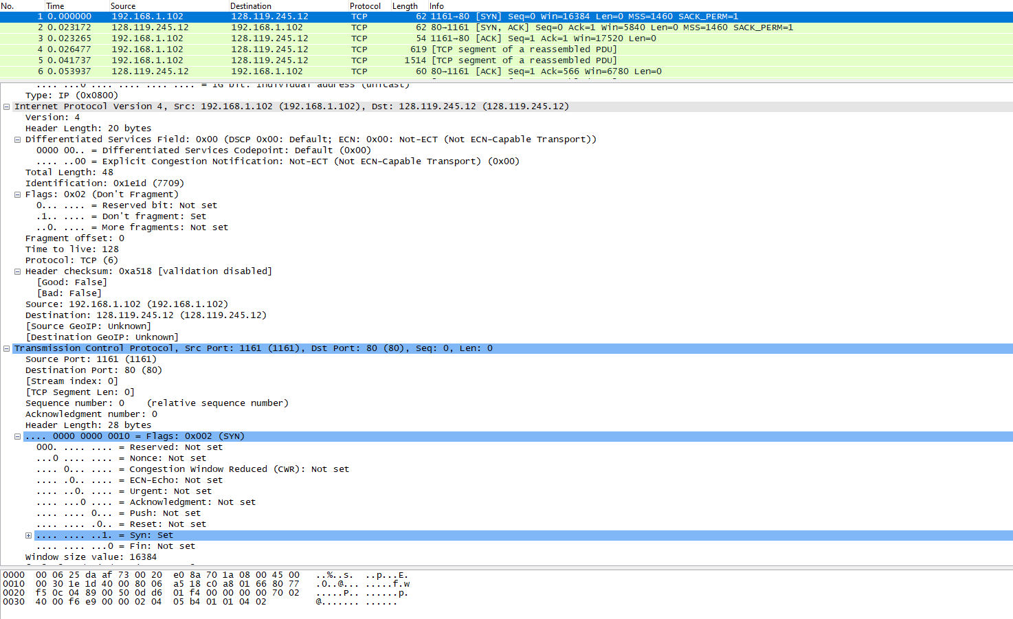

**Question no 2** 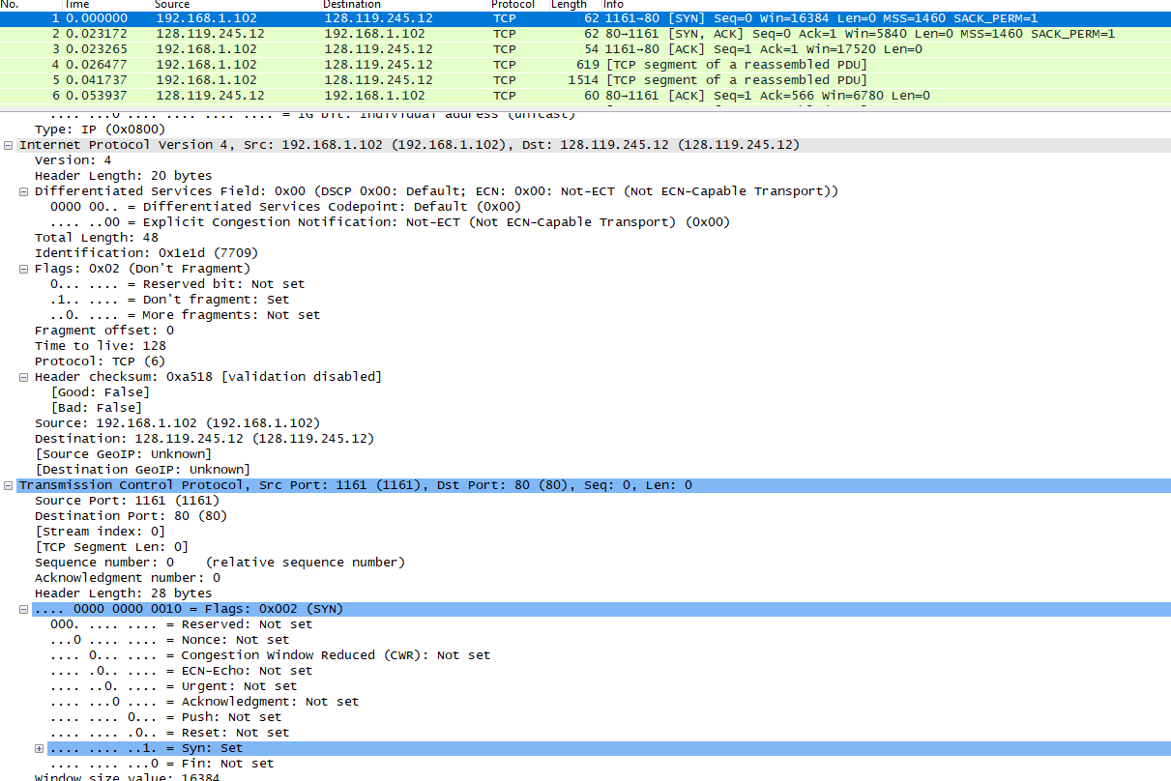

**Question no 3**

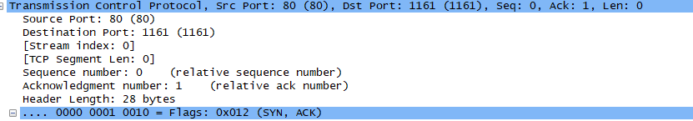

**Question no 4**

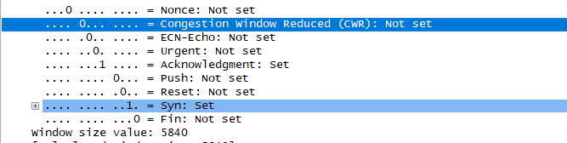

**Question no 5**

Signifies that previous packet has been received in sequence 1 Requesting next packet has the header value of 2026 in header This signifies that previous packet have been transmitted successfully

**Question no 6**

Signifies that previous packet has been received in sequence 1 Requesting next packet has the header value of 7866 in header This signifies that previous packet have been transmitted successfully

**Question no 7**

Using relative sequence numbers is a usability enhancement. This makes the numbers easier to read and compare

**In lab statement 2:**

**UDP**

**Question no 1**

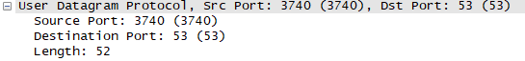

**Question no 2**

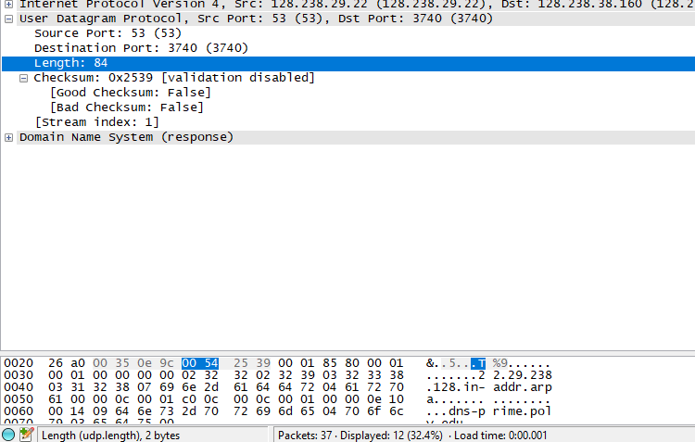

**Question no 3**

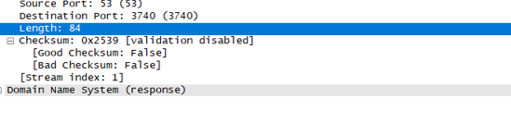

**Question no 4**

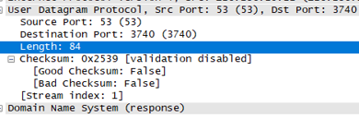

**In lab statement 3:**

1. They are sent of TCP

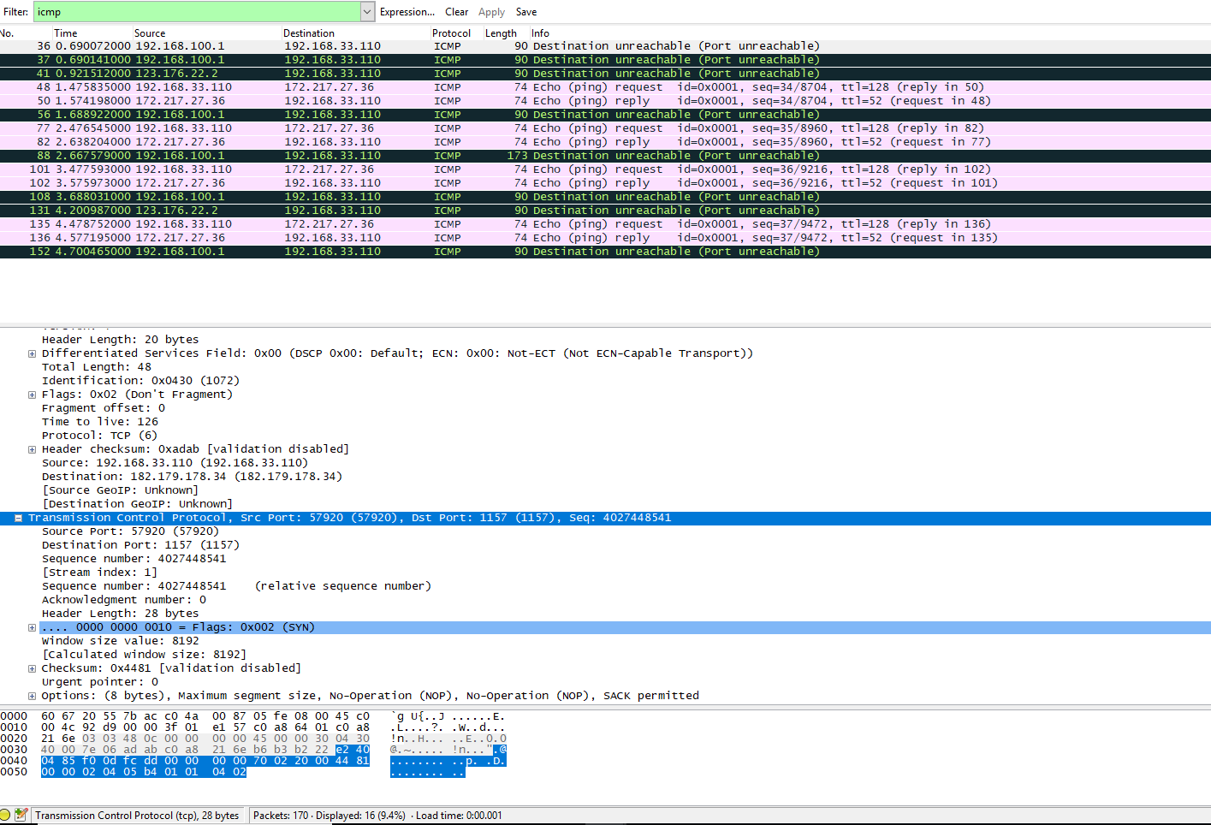

1. Link-layer address of host: 60:67:20:55:7b:ac 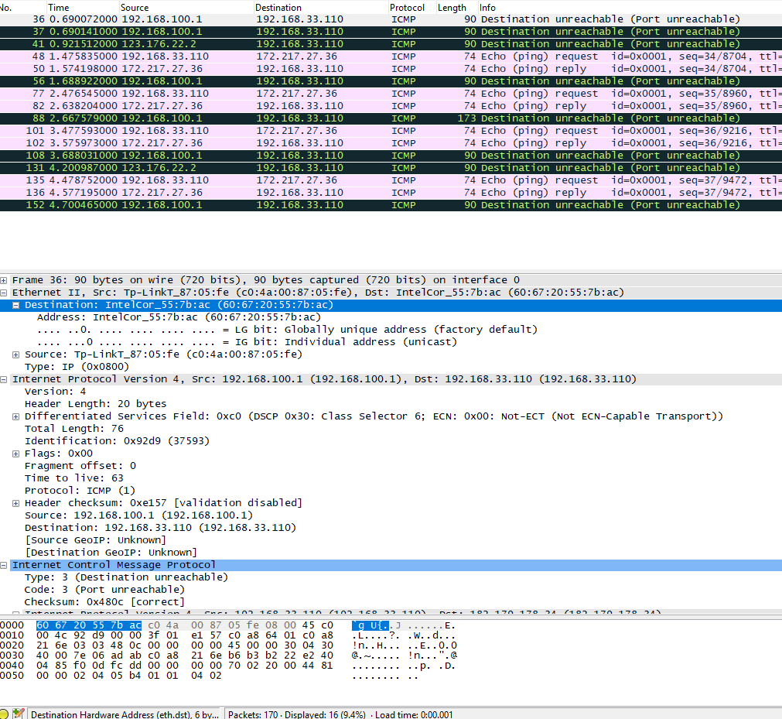
2. 2 requests are sent through host 1: TYPE 8: (echo (ping)request) 2:TYPE 0: (echo (ping)reply)
3. There are 4 accepted requests that are sent through the host.
4. Source IP: 192.168.33.110

Destination IP: 172.217.27.36

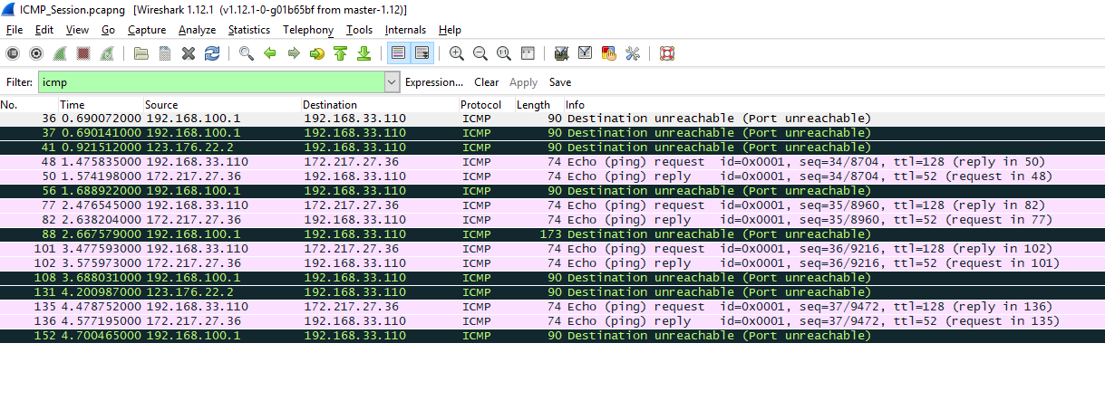

1. ICMP can only communicate between network layers hence, it has no source and destination port numbers.
2. Their type numbers differentiates request message from reply message. Request message has TYPE: 8 and reply messages has TYPE: 0
3. ICMP type is 8 and code number is 0

Checksum bytes are 0x4de39, sequence number bytes are 8995 (8960+35), identifier field has bytes 257(256+1)

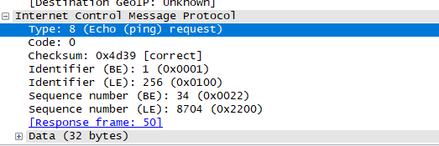

1. ICMP type is 0 and code number is 0

Checksum bytes are 0x4de39, sequence number bytes are 8738 (8704+34), identifier field has bytes 257(256+1)

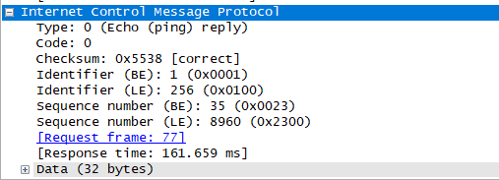

1. TYPE: 3

Code: 3

IP and TCP Header included in the ICMP Header for error handling and to help understand the error.